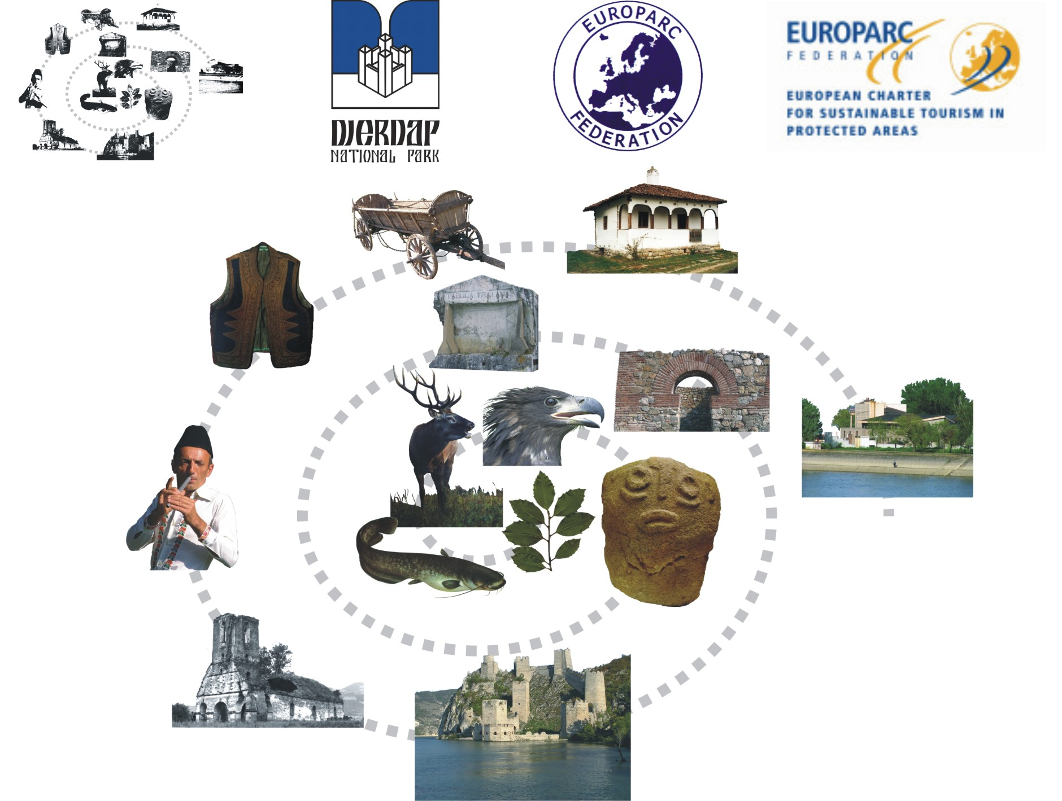
Sustainable Tourism in Protected Areas - Building Bridges - Seeking Solutions
VIIth EUROPEAN CHARTER NETWORK MEETING
REGISTRATION FORM

DJERDAP NATIONAL PARK
DONJI MILANOVAC
28th -1st July 2011

PARTICIPANT’S DETAILS
Title:
Family Name:
First Name:
Organisation:
E-mail:

Position:
Dept./Div:
Address:
Zipcode:
City:
Country:
Mobile Phone:
Telephone:

Emergency Contact Person:
Name:
Relationship:
Telephone:

Special request: (allergies, health needs, etc…)

MY TRAVEL DETAILS
ARRIVAL INFORMATION:
I WILL ARRIVE – DATE: (gg/mm/yy) |  | TIME: (hh:mm)

NIKOLA TESLA AIRPORT | BELGRADE BUS STATION
BELGRADE RAILWAY STATION | OTHER
DEPARTURE INFORMATION:
I WILL LEAVE – DATE: (dd/mm/yy) |  | TIME: (hh:mm)

NIKOLA TESLA AIRPORT | BELGRADE BUS STATION
BELGRADE RAILWAY STATION | OTHER

HOW TO GET TO DJERDAP NATIONAL PARK

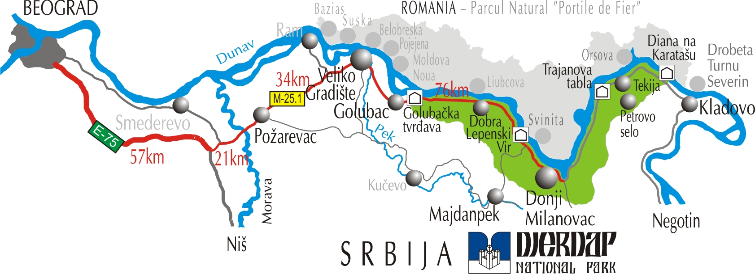

One main road pass trough the Majdanpek municipality M 25-1 (Požarevac – Veliko Gradište – Golubac – Donji Milanovac) linking it with the E 75 (highway Belgrade – Niš). Donji Milanovac is 197 km far away from Belgrade.
WORKSHOP 29th JUNE

Workshop 1: Introduction to the European Charter for Sustainable Tourism in Protected Areas

Workshop 2: Organising tourism inside the Protected Area and in the Charter Network.

Workshop 3: Sustainable Tourism working in Partnership

Workshop 4: Reinforcing Social Cohesion with the European Charter for Sustainable Tourism

Workshop 5: Economic Benefits and Branding of Tourism products

Please indicate the workshop you want to attend:
1st choice: | Workshop number:
2nd choice: | Workshop number:

I WOULD LIKE TO BRING A DISPLAY OR POSTER FOR THE BOULEVARD OF EXPERIENCE:

EXCURSIONS 30th JUNE

EX1: VELIKI ŠTRBAC (description in additional information document)

EX2: KOVILOVO – RAJKO’S CAVE (description in additional information document)

EX3: VRATNA – RAJAČKE PIMNICE (description in additional information document)

EX4: CRUISING DOWN THE DANUBE THROUGH KAZAN TO TRAJAN’S PLAQUE (description in additional information document)

1st choice:
2nd choice:

ACCOMMODATION

I WOULD LIKE TO TO SHARE ROOM WITH:

COMMENTS: __________________________________________________________

Hotel accommodation is not covered and must be paid separately in advance. Due to a generous offer from the Hotel Lepenski Vir, all accommodation and meals from cocktails dinner on Tuesday 28th June to lunch on Friday 1st July are included for ONLY 129 €.
For additional nights out with the conference dates, rooms can be booked on per night basis for 43 €.

For more information about the hotel, please go to http://www.hotellepenskivir.co.rs

NOTE: We will book a room for you. Do not book independantly at the hotel.
You MUST however pay in EUROS directly to the hotel prior to arrival. You can pay by credit or debit card or by invoice. Please, check your declared address information is correct for invoicing.
If you will be paying by invoice, you will receive instructions for international bank transfer in EUROS ONLY... directly by e-mail!
I CHOSE TO PAY BY:
CARD | INVOICE

OTHER INVOICE ADDRESS:
Organisation/Company:
Address:
Zipcode:
City:
Country:

TERMS OF CANCELLATION: Notification of cancellation should be sent in English to conference@npdjerdap.org

